Outpatient Workup/Management of COVID-19- A Concise Guide
California Thoracic Society
Updated 4/2/2020

General Principles
- Coronavirus Disease 2019 (COVID-19) is caused by SARS-CoV-2, a novel coronavirus first reported in December 2019 in China. The incubation period ranges from 2-14 days with a reported median of about 5 days.
- There is no one test or symptom(s) that is 100% sensitive or specific for COVID-19. COVID-19 should be considered as part of the differential for any patient presenting with signs/symptoms of a viral illness. While upper/lower respiratory symptoms and fever are most common, patients may initially be afebrile or present with GI symptoms and go on to develop more classic symptoms a couple days later.
Sensitivity of currently available COVID-19 screening is improved with proper sampling--cotton swabs should not be used.
- To date, there is no vaccine and no specific antiviral medicine to prevent or treat COVID-19. WHO does not recommend self-medication with any medicines, including antibiotics, as a prevention or cure for COVID-19. The use of any medication for which efficacy has not been demonstrated in controlled clinical trials is not recommended for mild cases of COVID-19 treated in the outpatient setting.
Clinical trials investigating the use of hydroxycholoroquine either as treatment or for pre/post exposure prophylaxis are ongoing https://clinicaltrials.gov/ct2/results?recrs=ab&cond=COVID&term=hydroxychloroquine&cntry=US&state=&city=&dist=
- As with any viral illness, patients with mild disease* and no risk factors for serious illness** can be given instructions to care for themselves at home. Some reports suggest the potential for clinical deterioration during the second week of illness and recommend that patients at risk for severe disease get a home pulse oximeter. Use of smartphones is not recommended.
- Current medication regimens for patients (without evidence of COVID-19) with pre-existing conditions such as chronic lung disease, heart failure, rheumatologic diseases do not need to be changed. This includes the use of inhaled corticosteroids (ICS), ACE-I/ARBs and immunomodulatory drugs.

Table of Contents
- Overview
- Spectrum of disease
- Presenting signs and symptoms
- COVID-19 Screening
- Triage
- Treatment
- References

Overview:
The coronaviruses are a large family of viruses that usually cause mild to moderate upper respiratory tract illnesses, like the common cold, in people.
Most coronaviruses circulate among animals including pigs, camels, bats and cats. Only seven coronaviruses are known to cause human disease, four of which are mild.
Three of the coronaviruses have been associated with serious disease in people. These diseases are SARS (severe acute respiratory syndrome), which emerged in late 2002 and disappeared by 2004; MERS (Middle East respiratory syndrome), which emerged in 2012 and remains in circulation in camels; and COVID-19 (Coronavirus disease 2019). COVID-19 is caused by the novel coronavirus SARS-CoV-2. Based on genetic sequencing, the virus is thought to have originated in November 2019 in the city of Wuhan, China. There is no evidence to indicate that the virus originated in a laboratory. (1)
The number of cases continues to rapidly rise in the state of California. On March 19, 2020, the state ordered all residents to stay at home or place of residence unless they are required to maintain continuity of operations in 16 identified federal critical infrastructure sectors
https://www.cisa.gov/identifying-critical-infrastructure-during-covid-19
Current medication regimens for patients (without evidence of COVID-19) with pre-existing conditions such as chronic lung disease, heart failure, rheumatologic diseases do not need to be changed. This includes the use of inhaled corticosteroids (ICS) in asthma and ACE-I/ARBs in hypertension. There is no evidence that routine discontinuation of treatment is beneficial. (2) For patients on immunomodulatory therapies, any changes should be made in close consultation with the patient's physician as discontinuing these medications may result in loss of response when the agent is reintroduced.

Spectrum of disease:
A recent analysis by Johns Hopkins Public Health indicates that slightly >97% of people who develop symptoms of SARS-CoV-2 infection will do so within 11-12 days of exposure, with a median incubation period of about 5 days. In contrast, human coronaviruses that cause common colds have mean incubation periods of about three days. (3) Public health recommendations of a 14-day quarantine period are designed to minimize both transmission as well as the individual and societal costs of quarantine.
COVID-19 should be considered as part of the differential for any patient presenting with signs/symptoms of a viral illness. While upper/lower respiratory symptoms and fever are most common, patients may initially be afebrile or present with GI symptoms and go on to develop more classic symptoms a couple days later.
The spectrum of illness ranges from mild to critical. Most infections are not severe.
●Mild (no or mild pneumonia) reported in 81%.
●Severe disease (e.g., with dyspnea, hypoxia, or >50% lung involvement on imaging within 24 to 48 hours) reported in 14%
●Critical disease (e.g., with respiratory failure, shock, or multi-organ dysfunction) reported in 5%.
●The overall case fatality rate was 2.3%. No deaths were reported among noncritical cases.
Note, that these data are based on a Chinese cohort of >72,000, up through February 2020 that was published in JAMA. (4) Case fatality rates do vary between countries. (5) Based on CDC/MMWR report looking at severe outcomes in patients with COVID-19 from Feb 12 - Mar 16, it appears that the US case fatality rate may be slightly lower, holding steady at 1.3% (6). Importantly, severe illness leading to hospitalization, including ICU admission and death, can occur in adults of any age with COVID-19. (6)

Presenting Signs and Symptoms
COVID-19 should be considered as part of the differential for any patient presenting with signs/symptoms of a viral illness. While upper/lower respiratory symptoms and fever are most common, there are patients who initially may be afebrile or present with GI symptoms and go on to develop more classic symptoms a couple days later.

Constitutional
  - Fever (77-98%). The fever course among patients with COVID-19 may be prolonged and intermittent. Patients can be afebrile at presentation.
  - Myalgia (11-15%)
  - Headache (8-34%)

Upper respiratory
  - Rhinorrhea (5-24%)
  - Sore throat (5-14%)

Lower respiratory
- Cough (68-82%)
- Dyspnea (3-64%)
- Sputum (14-56%)
- Hemoptysis (1-5%)

Gastrointestinal (can be initial presentation)
- Nausea/vomiting (1-10%)
- Diarrhea (2-8%)
- Loss of appetite (reported as a negative prognostic sign)

COVID-19 Screening
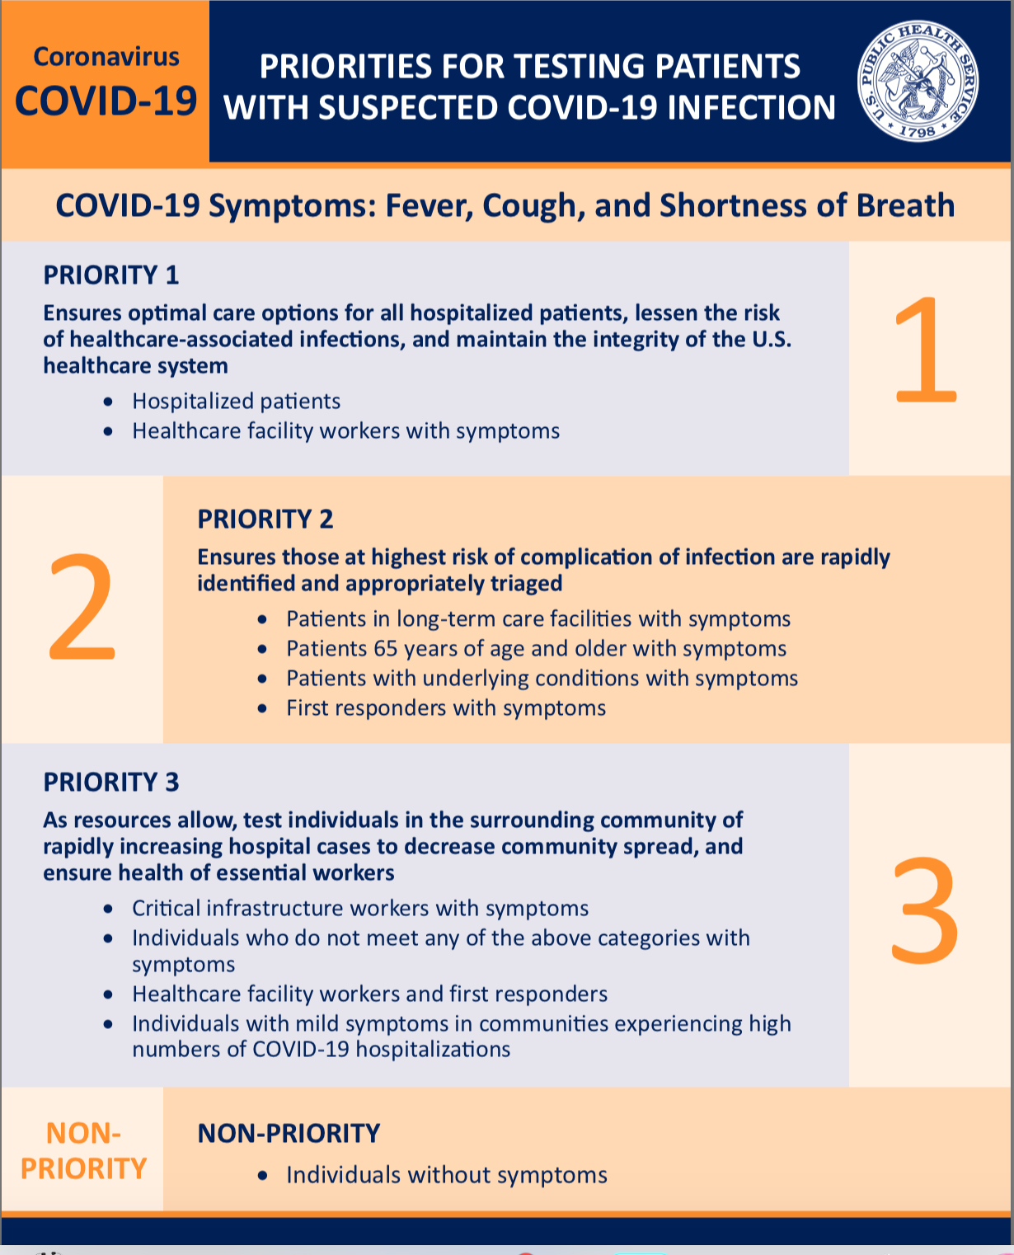
The CDC has defined priority categories to guide who should be tested. Testing is recommended for priority 1 and 2. Patients in the priority 3 category should be tested depending on resource availability. Many labs are overwhelmed, leading to several day delays in test results.

Estimates of testing sensitivity, depending on the platform used, are as low as 64-75%. Sensitivity can be decreased by low viral load (.e.g. early on during illness) or inadequate sampling. Samples that are initially negative may become positive with repeat testing, as symptoms worsen. Also, some patients appear to have primarily lower respiratory tract disease.
Although you no longer need to rule out influenza in order to test for COVID-19, testing for both viruses is encouraged. Estimates of co-infection are as high as 20%. Co-infection with influenza or other respiratory viruses may be a risk factor for severe illness. Depending on the lab, two samples may be required if respiratory pathogen or influenza testing is requested in addition to COVID-19
Swirl and Twirl — a good nasopharyngeal swab requires several seconds of swirling and twirling. Do not use a cotton swab!

The CDC guidance for obtaining an influenza swab should be followed for COVID-19 testing:
Materials
Sterile Dacron/nylon swab
Viral transport media tube (should contain 1-3 ML of sterile viral transport medium)
Proper PPE
Procedure
- Tilt patient’s head back 70 degrees.
- Insert swab into nostril. (Swab should reach depth equal to distance from nostrils to outer opening of the ear.) Leave swab in place for several seconds to absorb secretions.
- Slowly remove swab while rotating it.
- Place tip of swab into sterile viral transport media tube and snap/cut off the applicator stick
Video demonstration: https://www.youtube.com/watch?v=DVJNWefmHjE

Other testing:
In general, laboratory testing has not been found to be helpful to rule-in or rule-out COVID-19; but may provide circumstantial evidence of infection.
CBC
- Lymphopenia (83%)
- Leukocytosis (24 - 30%) or leukocytopenia (9-25%)
- Thrombocytopenia (36%) (associated with poor prognosis?)

Other labs
1. LFTs (elevated AST/ALT 34%)
2. LDH
3. CRP elevated (If normal, look for another cause of symptoms)
4. Procalcitonin

Radiology (not necessary in mild disease)
CXR abnormal in 60% (77% if severe), chest CT abnormal in 86% (95% if severe)
• Unilateral findings on CXR or CT in 14-25% (especially if mild or early in disease)
• Most common findings: GGO and patchy consolidation (>50%), peripheral distribution >50%
• Nodules, lymphadenopathy, cystic changes, effusion in <10%

Triage
One of the most important decisions that must be made during an outpatient evaluation is whether the patient should be admitted/sent for further respiratory evaluation or can be sent home. These decisions may be affected by the situation in your local ER/Urgent Care and hospital.

*MILD DISEASE/absence of risk factors
Afebrile
No hypoxia or evidence of pneumonia
No malaise, confusion, lethargy

**Risk factors for SEVERE/FATAL DISEASE
Environmental risks
-High-risk travel or known COVID exposure within 14 days
-Health care workers
-Institutional home setting (nursing home, dormitory, shelter, prison, etc.), outpatient dialysis center patient

Patient-related risks
-Age > 60
-Immunocompromised (oncology, transplant, immunosuppressive meds, HIV, other known immunodeficiency)
-Pregnancy
-Chronic lung disease
-Cirrhosis
-Cardiovascular disease
-End stage renal disease
-Diabetes
-Hypertension

Criteria for home care (CDC)
- The patient is stable enough to receive care at home.
- Appropriate caregivers are available at home.
- There is a separate bedroom where the patient can recover without sharing immediate space with others.
- Resources for access to food and other necessities are available.
- The patient and other household members have access to appropriate, recommended personal protective equipment (at a minimum, gloves and facemask) and are capable of adhering to precautions recommended as part of home care or isolation (e.g., respiratory hygiene and cough etiquette, hand hygiene).
- There are household members who may be at increased risk of complications from COVID-19 infection (e.g., people >65 years old, young children, pregnant women, people who are immunocompromised or who have chronic heart, lung, or kidney conditions).

If moderate disease and/or risk factors present, consider further evaluation including labs, CXR or send to Urgent Care/ER

Treatment
To date, there is no vaccine and no specific antiviral medicine to prevent or treat COVID-2019. WHO does not recommend self-medication with any medicines, including antibiotics, as a prevention or cure for COVID-19.
- Given the lack of controlled trials, and potential for toxicity, the use of chloroquine or hydroxychloroquine is not recommended in the outpatient setting. In particular, recent data exploring the use of azithromycin + hydroxychloroquine should be interpreted with extreme caution. (7,8)

*On March 28, 2020, FDA issued an EUA to allow hydroxychloroquine sulfate and chloroquine phosphate products donated to the Strategic National Stockpile (SNS) to be distributed and used for certain hospitalized patients with COVID-19. These drugs will be distributed from the SNS to states for doctors to prescribe to adolescent and adult patients hospitalized with COVID-19, as appropriate, when a clinical trial is not available or feasible. The EUA requires that fact sheets that provide important information about using chloroquine phosphate and hydroxychloroquine sulfate in treating COVID-19 be made available to health care providers and patients, including the known risks and drug interactions. The SNS, managed by ASPR, will work with the Federal Emergency Management Agency (FEMA) to ship donated doses to states.

- Although WHO backed off on their recommendation to avoid NSAIDs in COVID infection (March 19, 2020), there is no good data to support the use of NSAIDs during acute respiratory infections. Use of NSAIDs is associated with increased risk of heart attack and stroke in adults. In general, use the lowest effective dose for the shortest period of time. (9)
- No data to indicate that ICS need to be stopped in asthmatics. (2)
- Smoking cessation should continue to be recommended.
- In most cases, there is no need to specifically treat fever.

Treatment remains limited to supportive care, as for any mild viral illness.
Due to the potential for clinical deterioration during the second week of illness, some protocols recommend that patients at risk for severe disease get a home pulse oximeter, The use of smartphones to measure oxygen saturation is not recommended. (10)
1. Rest.
2. Drink plenty of clear fluids (cautiously, in patients with CHF) — water, broth, and sports drinks (can dilute 50:50, to avoid excess sugar intake or avoid entirely in diabetics)
3. Consider using a humidifier or saline spray to help with a stuffy nose.
4. While there are no good date to support the use of Supplements in COVID-19, (11) the following may be considered:
a. Vitamin C (doses > 2000 mg can cause kidney stones, diarrhea and nausea)
b. Zinc
          - Food sources include red meat, poultry, oysters, fortified cereals, whole grains, beans and nuts
          - Tolerable upper limit (includes dietary intake) for adults 19 years and up = 40 mg
          - Supplements come in pill and liquid form
          - 3-5 days
c. Medicinal mushrooms (12)
1. Dried or fresh (chaga, maitake, reishi are the foundations, also cordyceps, enoki, royal sun blue, turkey tail and lion’s mane
2. Capsules and other preparations are commercially available for those who don’t cook

References:
- https://www.niaid.nih.gov/diseases-conditions/coronaviruses
- Inhaled Corticosteroids in Asthma during the COVID-19 outbreak
- Stephen A. Lauer, Kyra H. Grantz, Qifang Bi, Forrest K. Jones, Qulu Zheng, Hannah R. Meredith, Andrew S. Azman, Nicholas G. Reich, Justin Lessler. The Incubation Period of Coronavirus Disease 2019 (COVID-19) From Publicly Reported Confirmed Cases: Estimation and Application. Annals of Internal Medicine, 2020; DOI: 10.7326/M20-0504
- Wu Z, McGoogan JM. Characteristics of and Important Lessons From the Coronavirus Disease 2019 (COVID-19) Outbreak in China: Summary of a Report of 72 314 Cases From the Chinese Center for Disease Control and Prevention. JAMA 2020.
- Global COVID-10 Case Fatality Rates https://www.cebm.net/global-covid-19-case-fatality-rates/
- Severe Outcomes Among Patients with Coronavirus Disease 2019 (COVID-19) — United States, February 12–March 16, 2020. MMWR Morb Mortal Wkly Rep. ePub: 18 March 2020
- https://jamanetwork.com/journals/jama/fullarticle/2763802
- https://www.cdc.gov/coronavirus/2019-ncov/hcp/therapeutic-options.html
- NSAIDS in Acute Respiratory Infections. https://www.cebm.net/oxford-covid-19/nsaids-in-acute-respiratory-infection/
- https://www.cebm.net/covid-19/question-should-smartphone-apps-be-used-as-oximeters-answer-no/
- https://www.thoracic.org/patients/patient-resources/resources/integrative-medicine.pdf
- Hobbs, Christopher PhD. Medicinal Mushrooms, https://www.christopherhobbs.com/library/featured-articles/mushroom-articles/ accessed 4/2/2020

CTS gratefully acknowledges its Executive Committee, under the leadership of President Laren Tan, Dr. Asha Devereaux, Chair Clinical Practice Committee and CTS’ editors: Dr. Angela Wang, Chris Garvey FNP, MSN, MPA, Dr. Sachin Gupta and Dr. Nancy Hsu

